**Work Integrated Learning Programs**

**MTech Software Engineering**



**API-Based Products**

**Assignment**

Submitted By

S. Anil Kumar Dora

2024TM93168

**GIT HUB LINK:**  
  
<https://github.com/AnilDora/API-Based-Products-Final-Assignment-plagiarism-.git>

**Question 1: Plagiarism Checker API using Cosine Similarity + ML**

**Goal:** Classify whether a student’s submission is plagiarized using text similarity and ML classification.

**Screenshot of some of plagiarism_checker:**

App.py

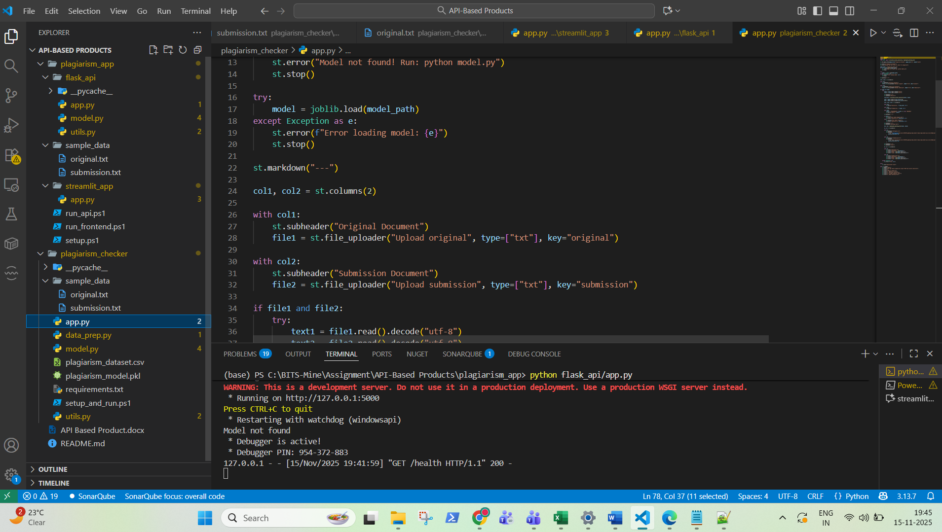

Model.py

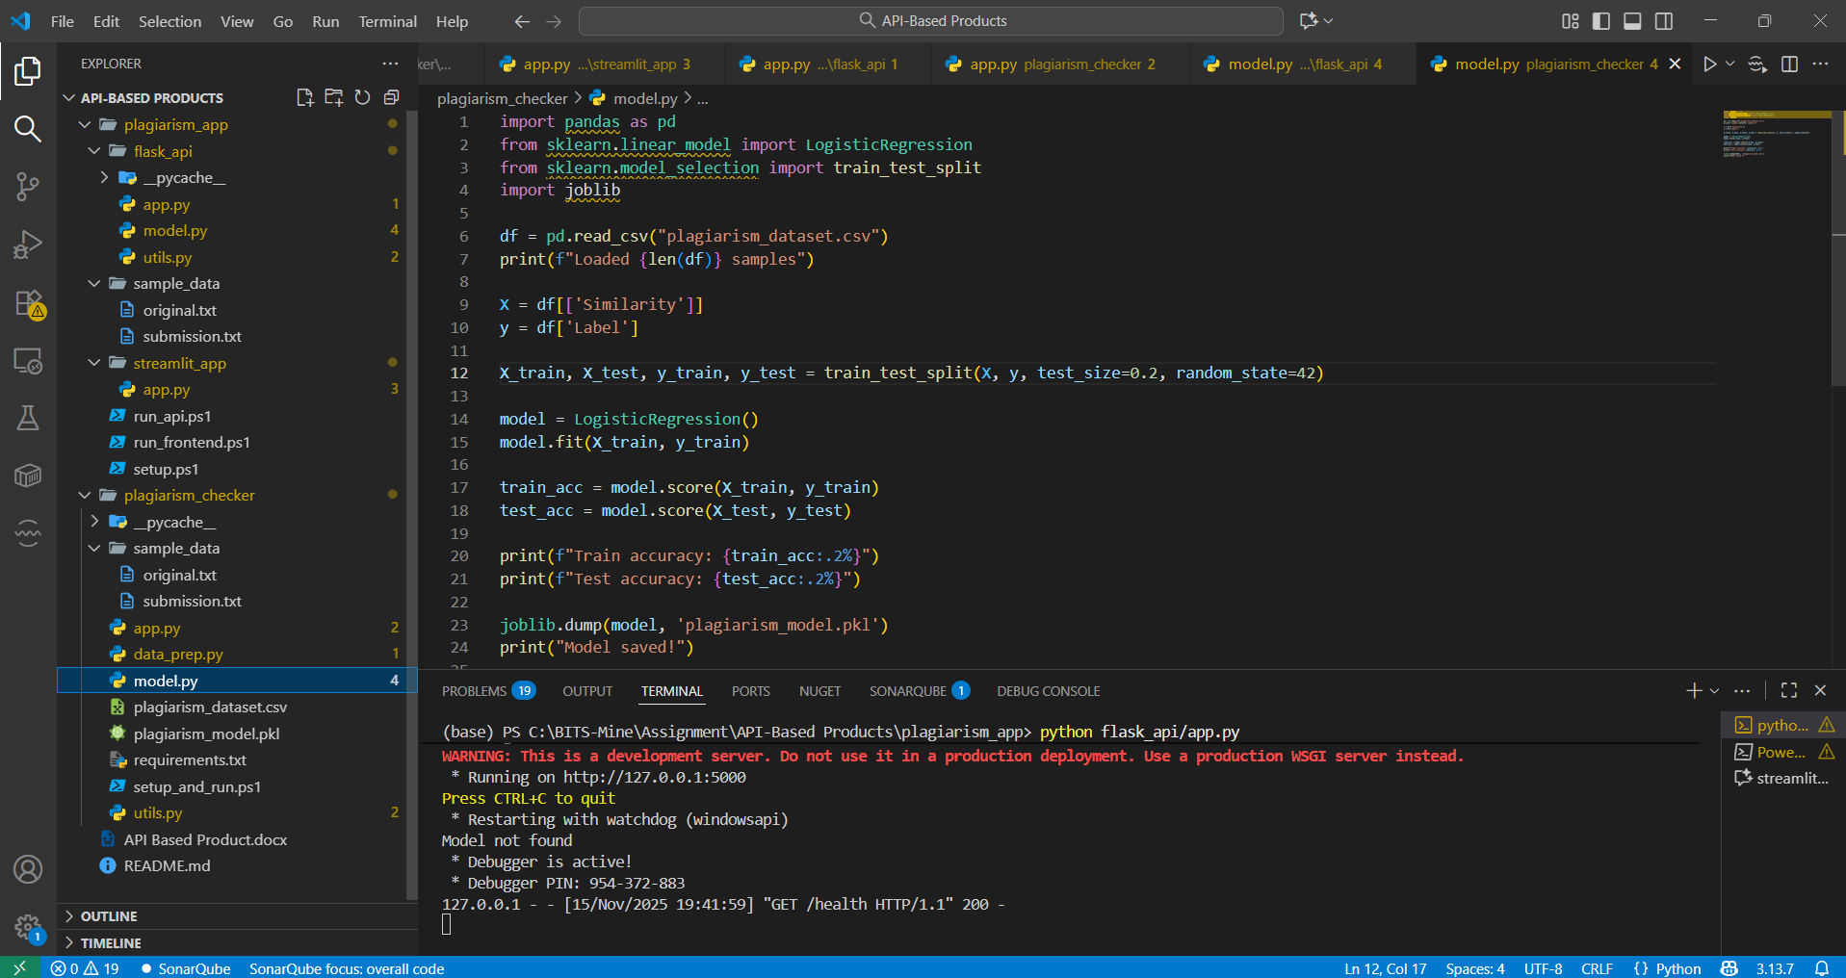

data_prep.py

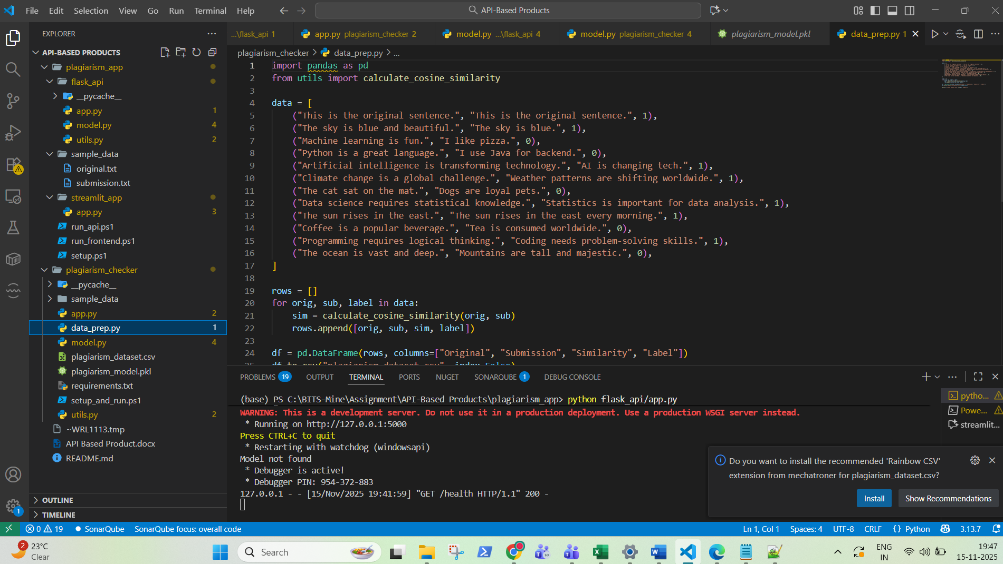

Utils.py

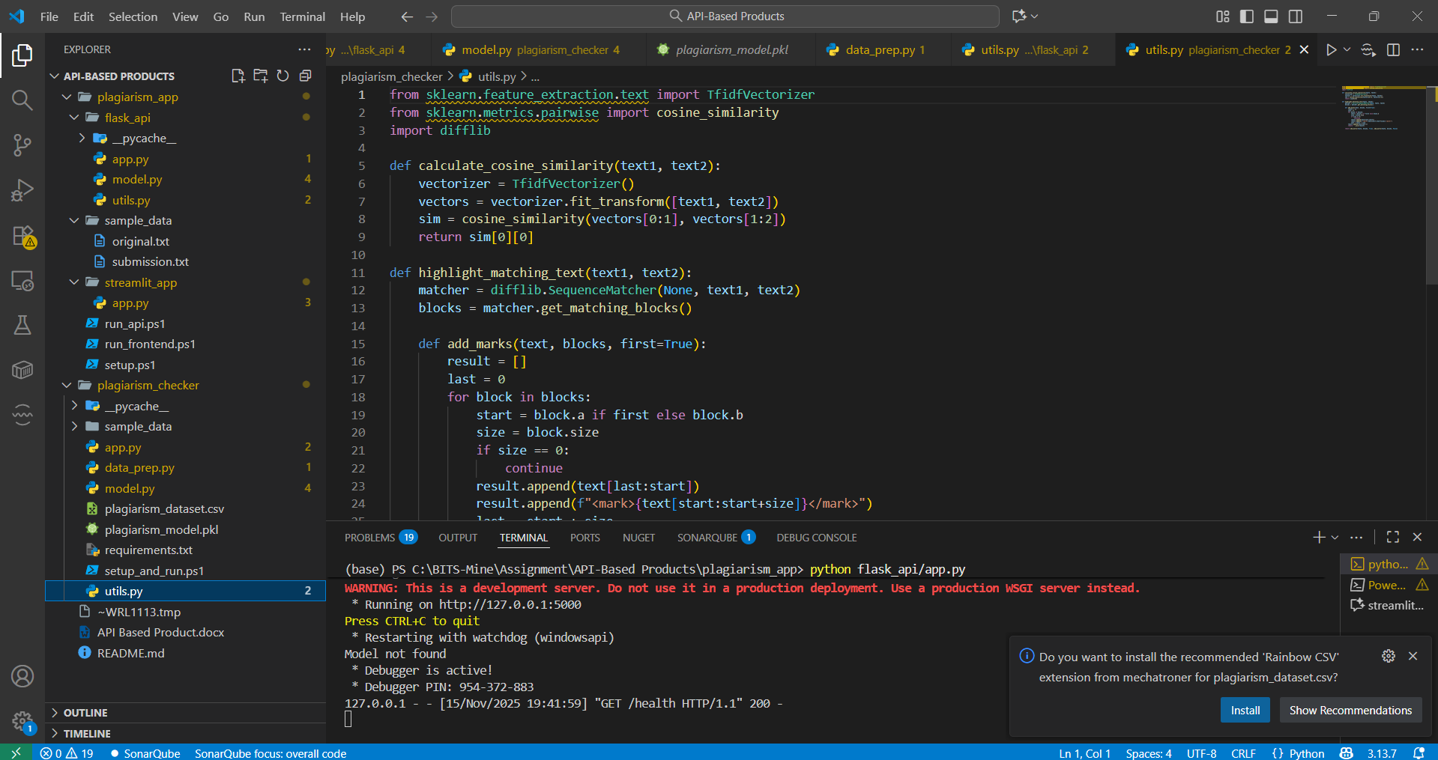

Reuirements Text:  
  
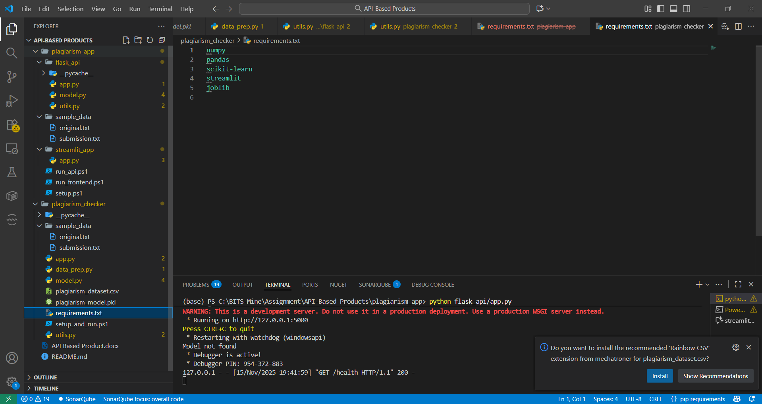

Git is used to tracking changes in the source code, enabling multiple developers to work together on non-linear development. Git makes collaborating on code easier.

**Screenshot of some of plagiarism_app:**

**app.py**

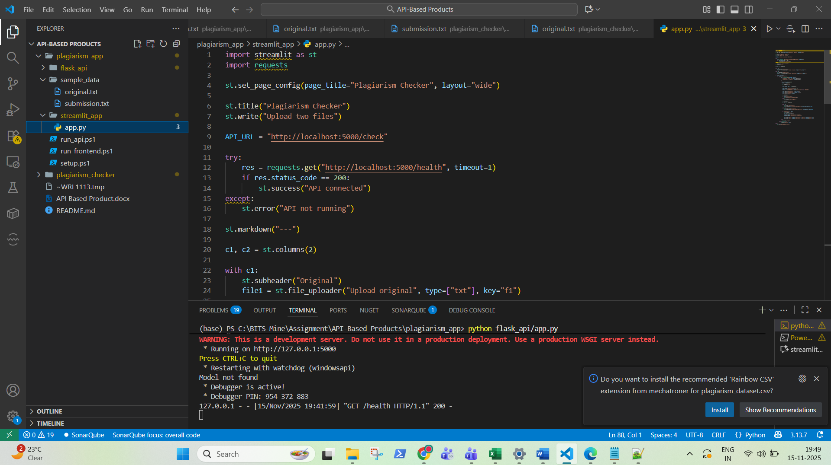

**App.py**

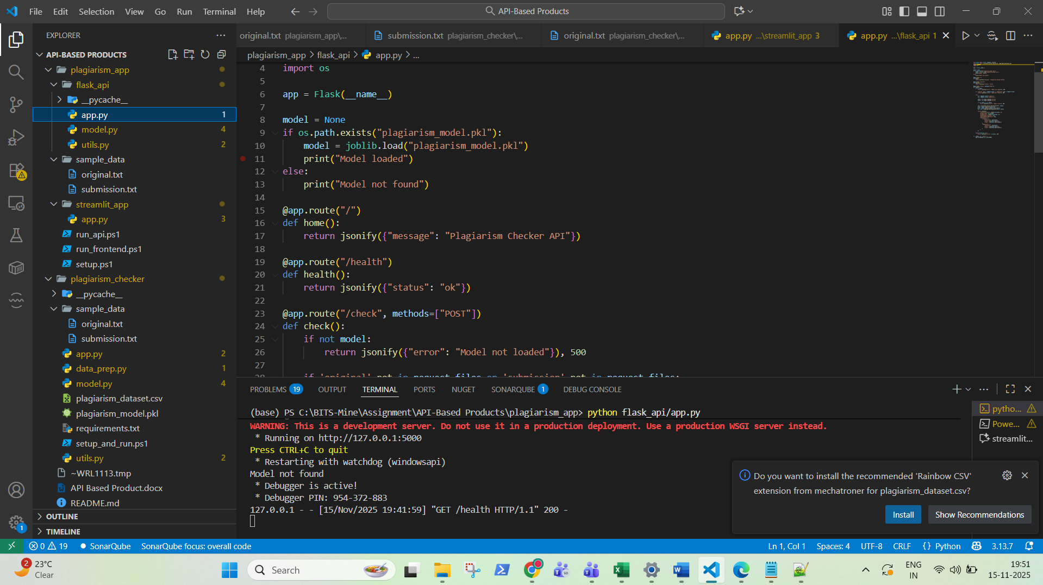

**Model.py**

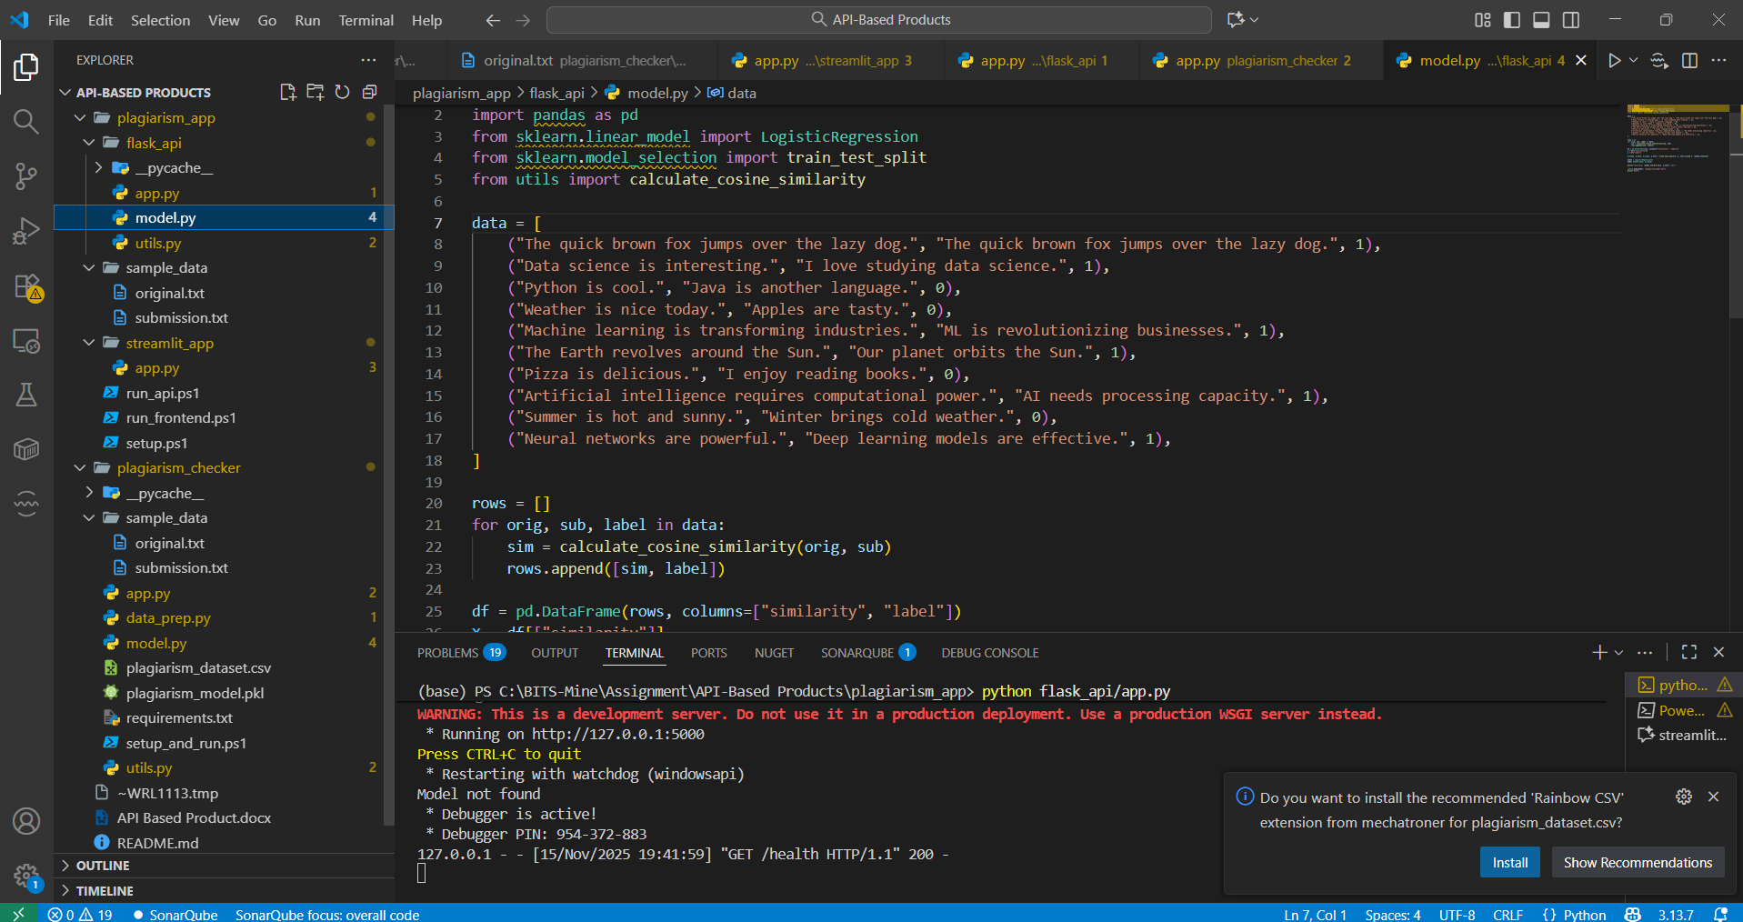

**Utils.py**

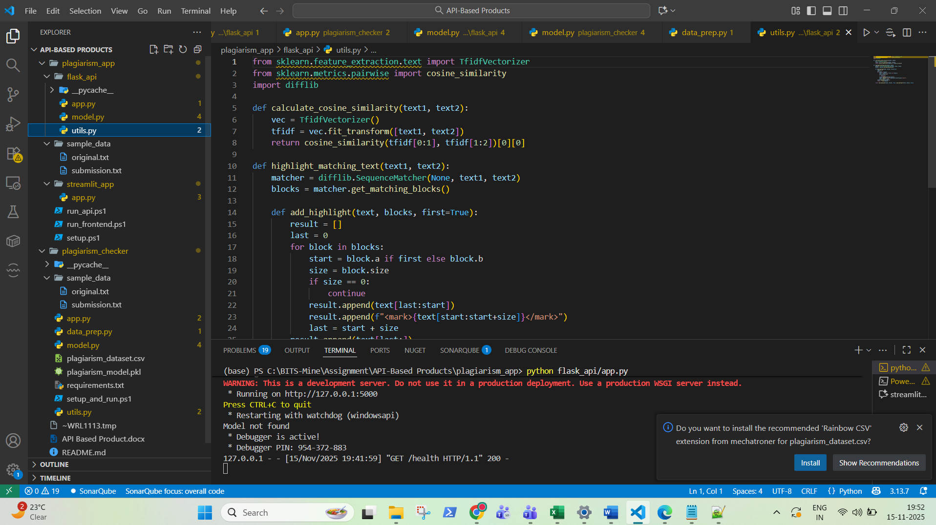

**Whole Project Structure:**

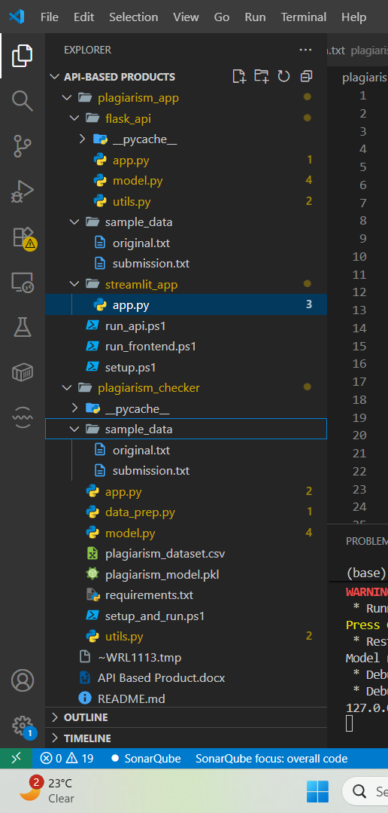

The plagiarism_checker app is running in 8052 port of localhost.

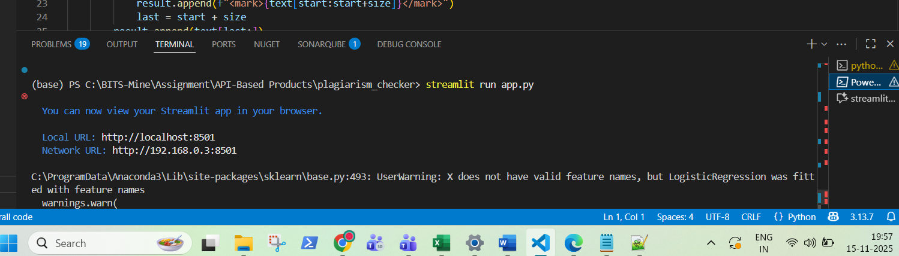

The plagiarism_app is running in 5000 port.

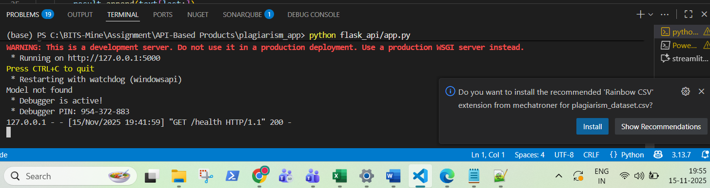

Some of the Apps Screenshot:

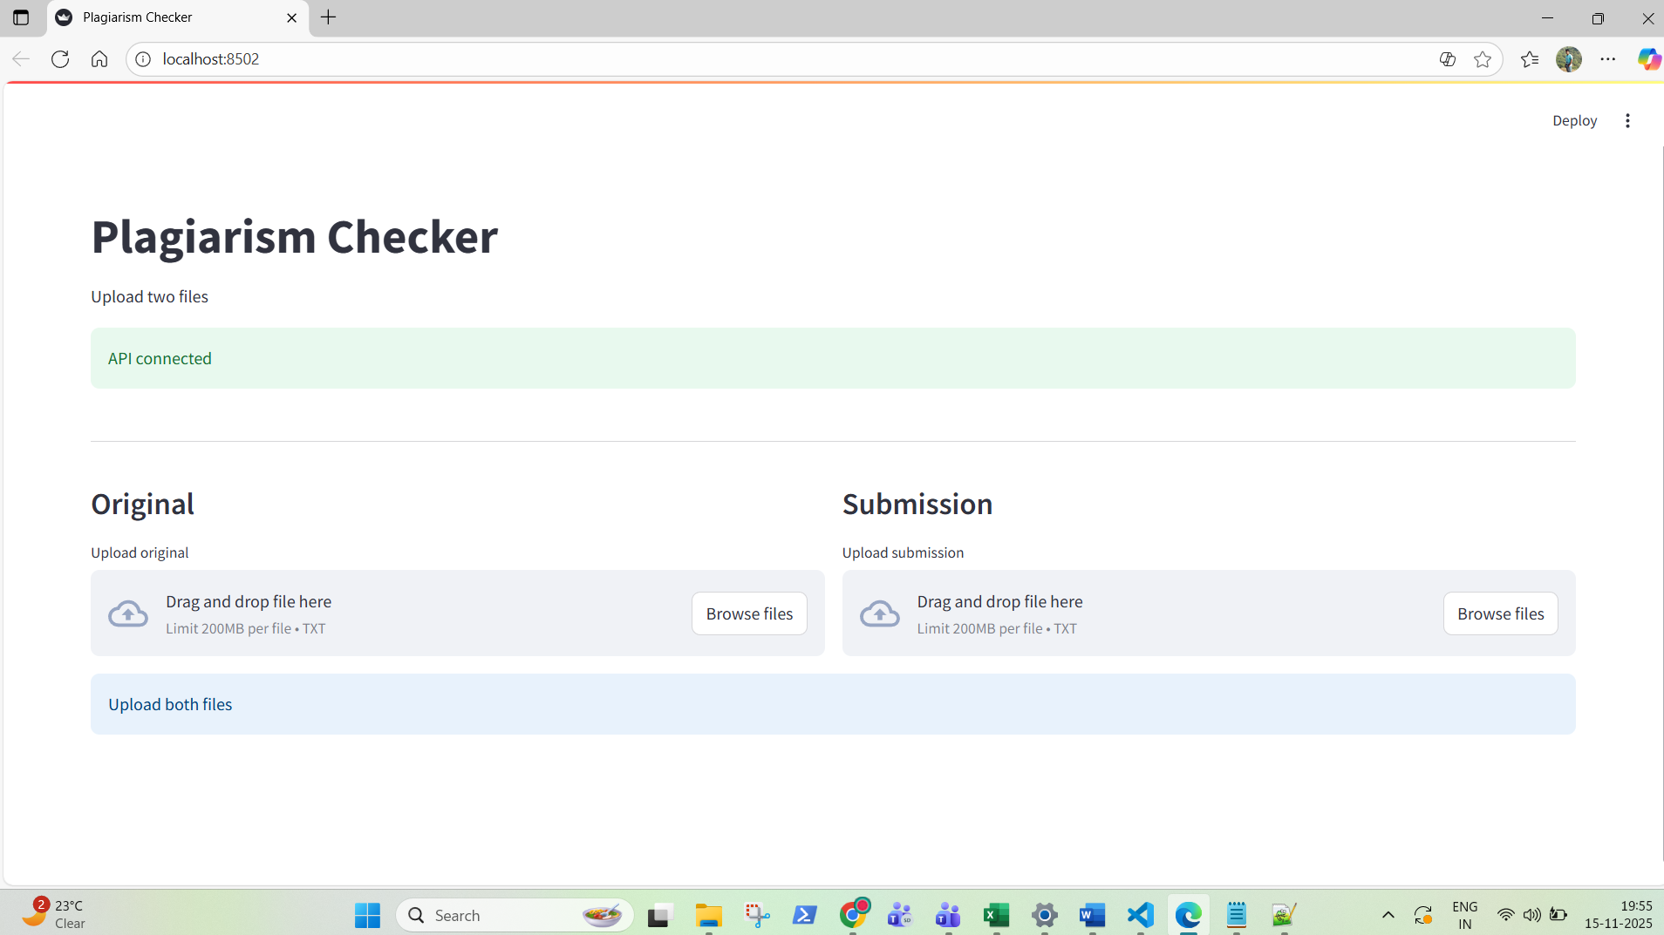

Uploading the original.txt

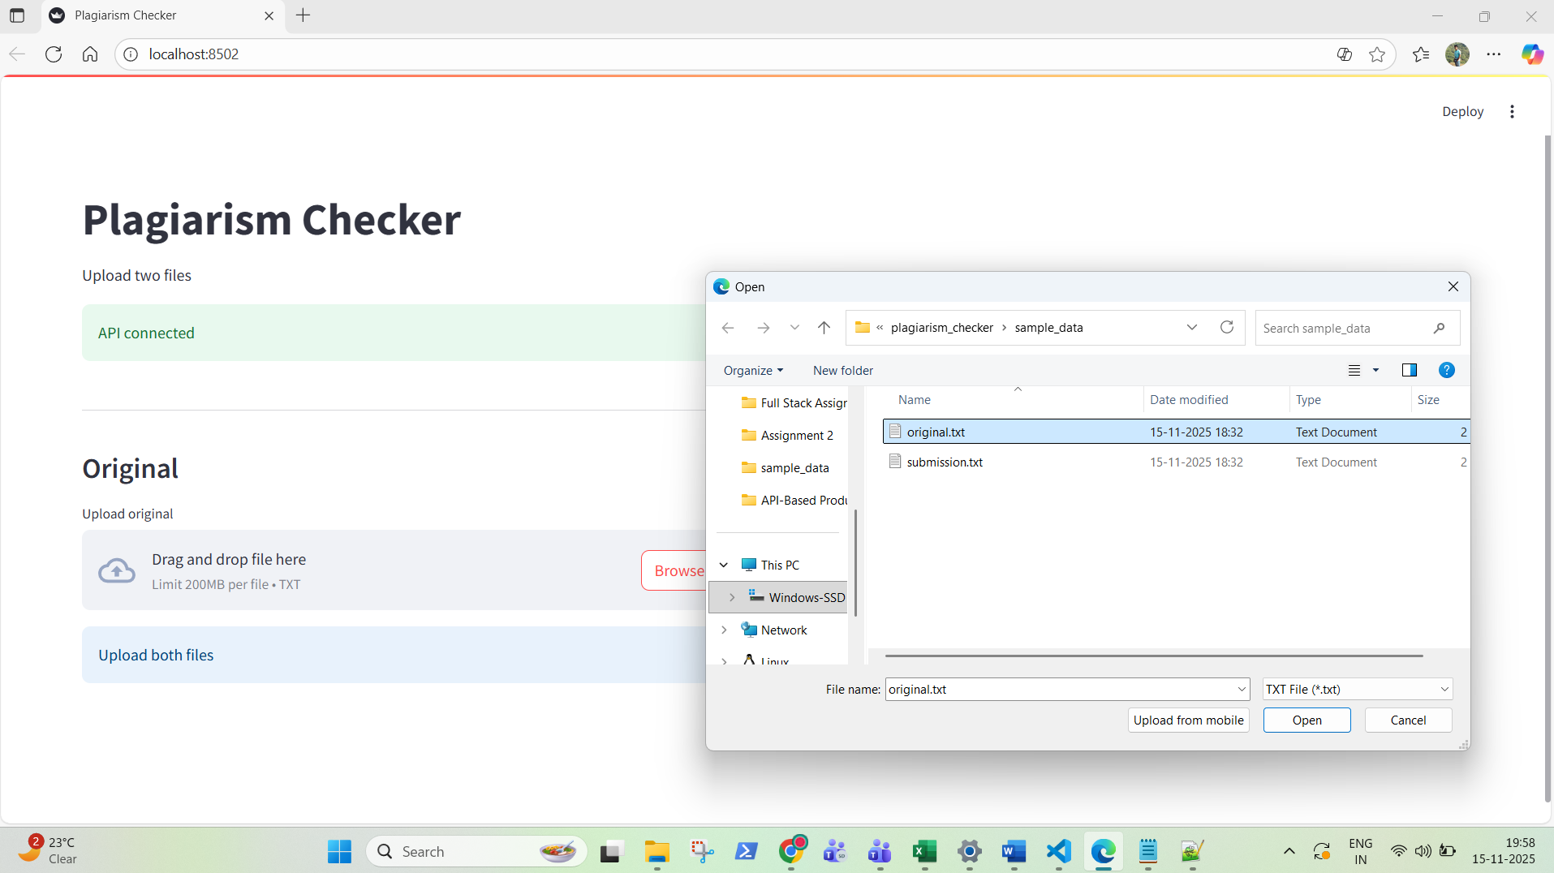

Uploading the submission.txt



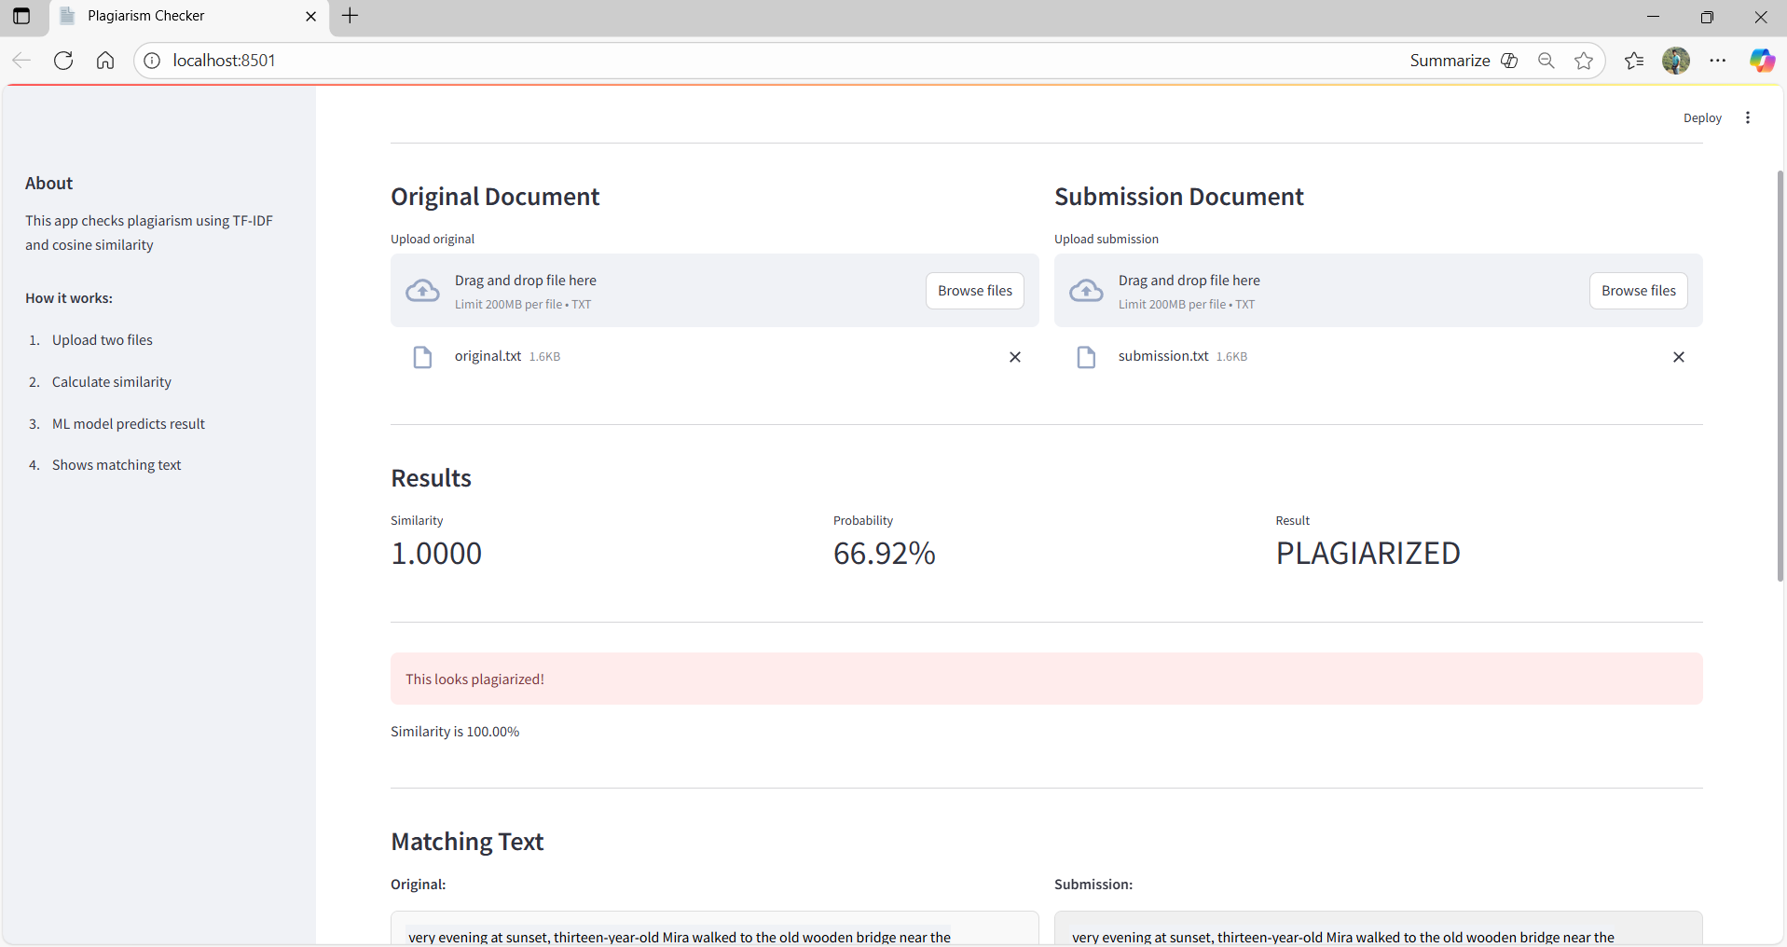

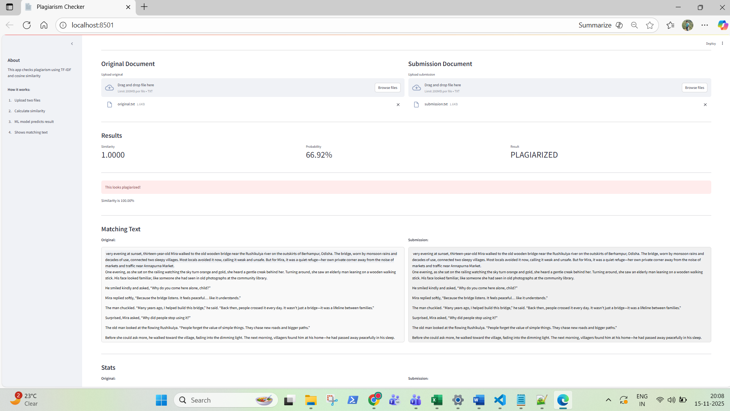

Now Showing Comparison for different files:

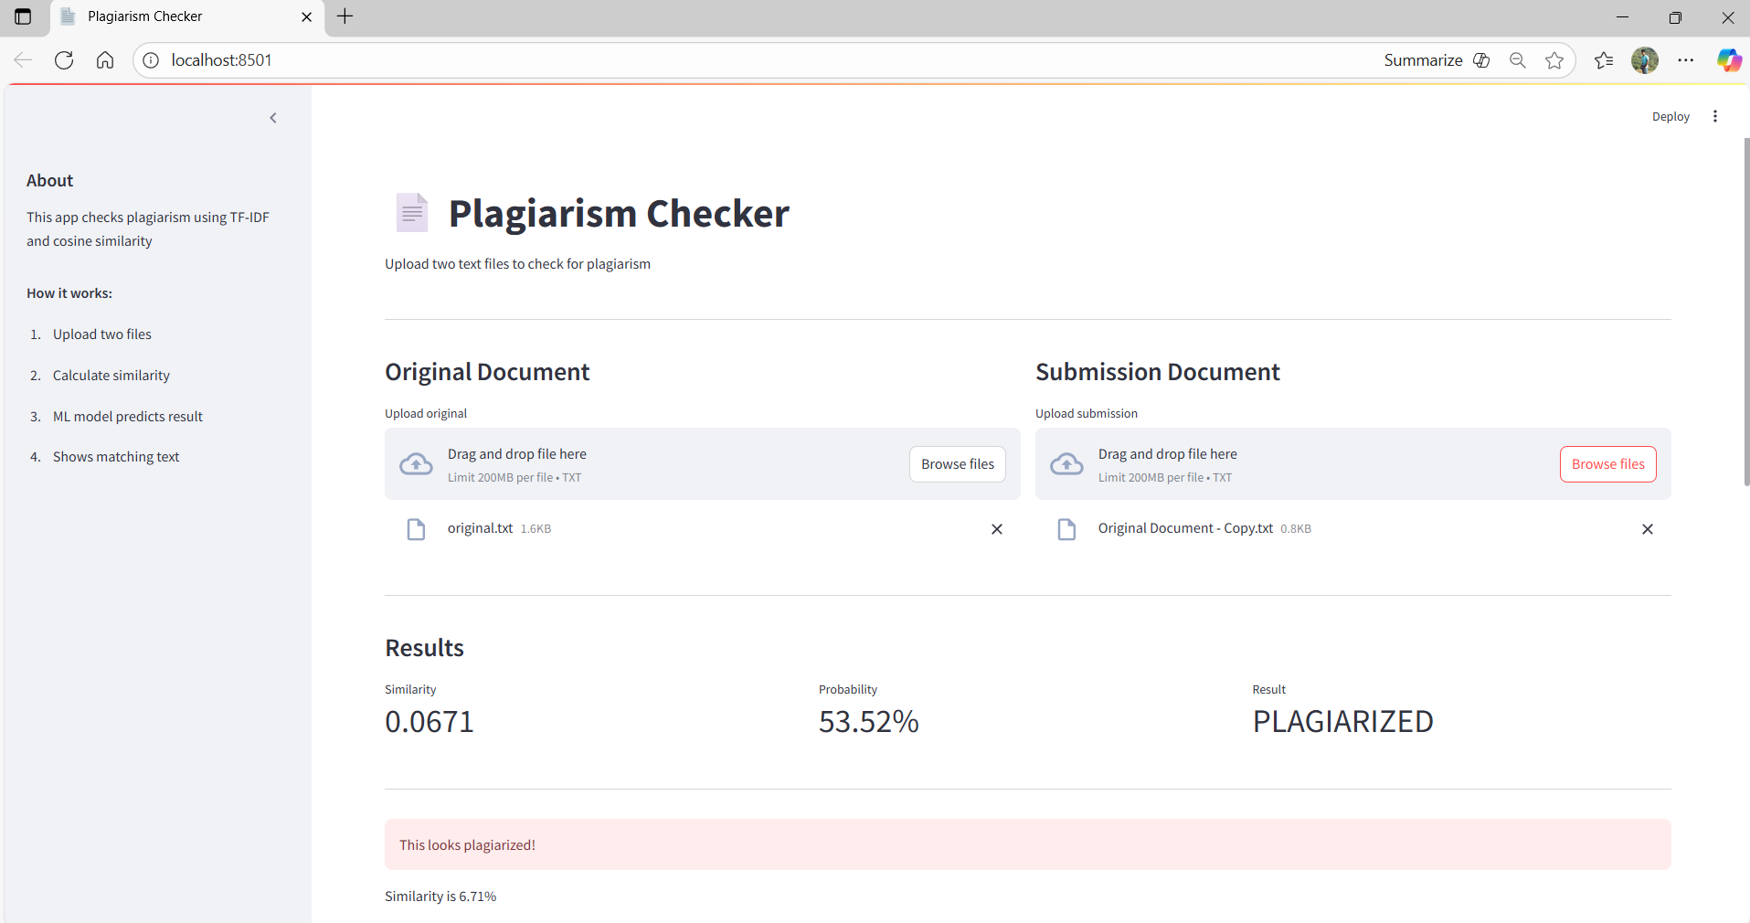

**Question 2: Perform rate limiting and request size limiting with KONG API Gateway.**

**Kong Features:**

* **Rate Limiting**: 100 requests per minute, 1000 per hour (returns 429 error when exceeded)
* **Request Size Limiting**: 10MB max (returns 413 error if exceeded)
* **Access through**: [http://localhost:8000](vscode-file://vscode-app/c:/Users/skdor/AppData/Local/Programs/Microsoft%20VS%20Code/resources/app/out/vs/code/electron-browser/workbench/workbench.html) (Kong proxy)
* **Direct API**: [http://localhost:5000](vscode-file://vscode-app/c:/Users/skdor/AppData/Local/Programs/Microsoft%20VS%20Code/resources/app/out/vs/code/electron-browser/workbench/workbench.html) (bypasses Kong)

Running images in Docker Desktop:

Docker File:

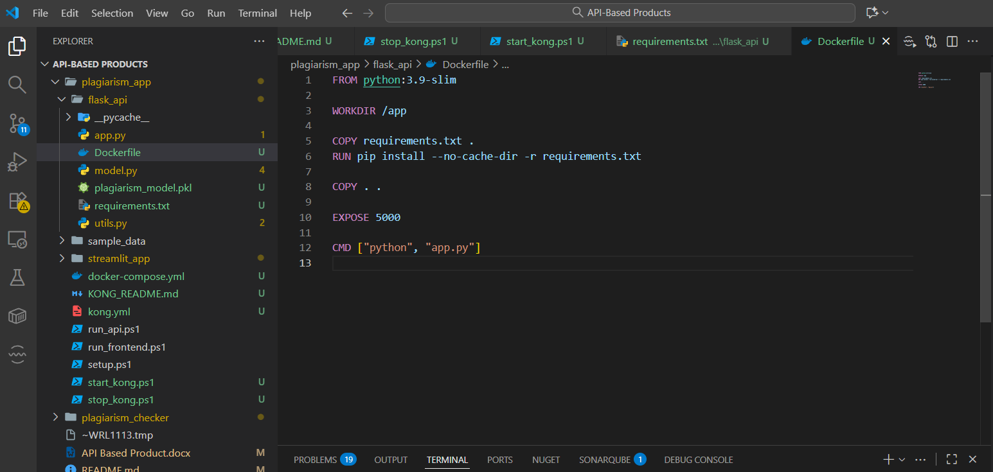

Docker Desktop:

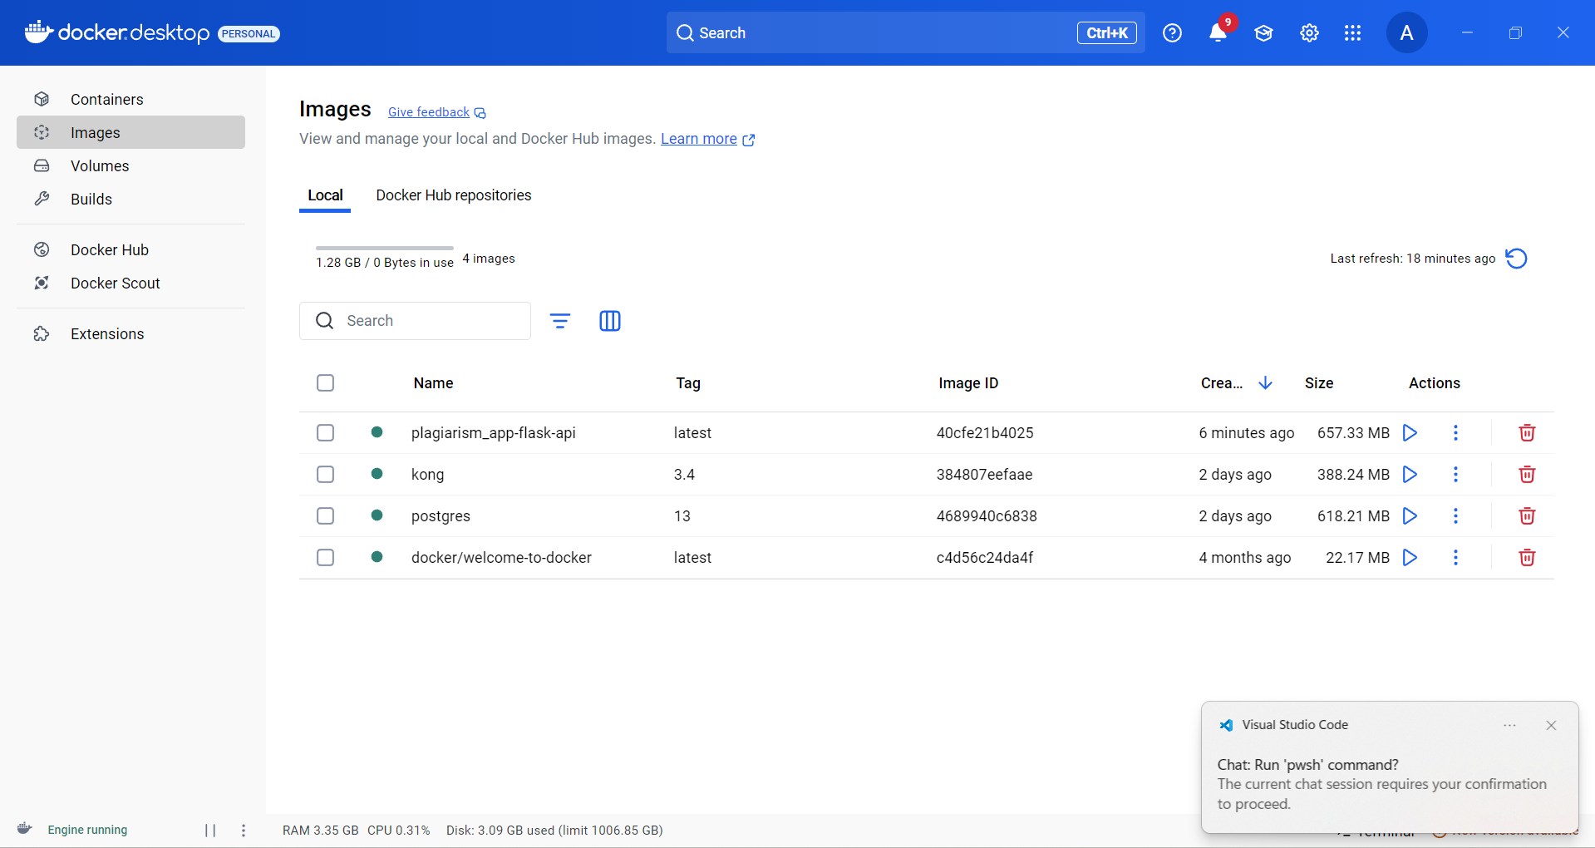

Testing Rate limit:

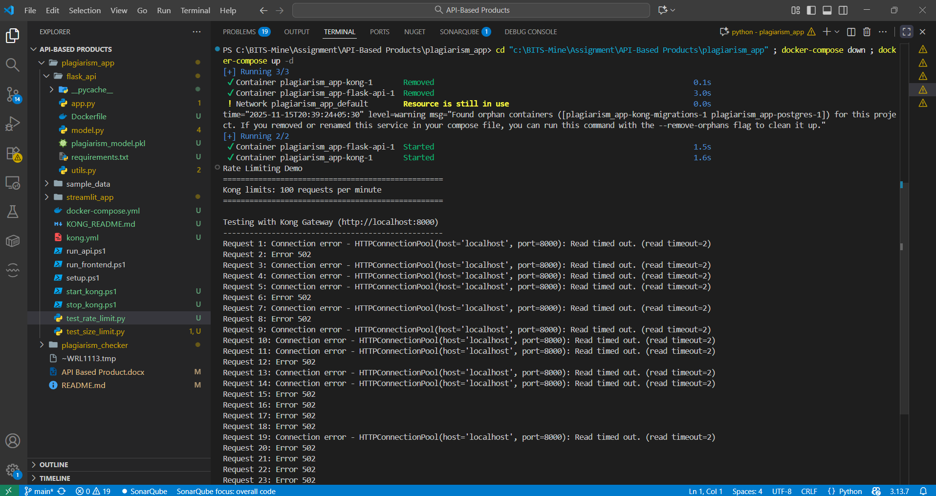

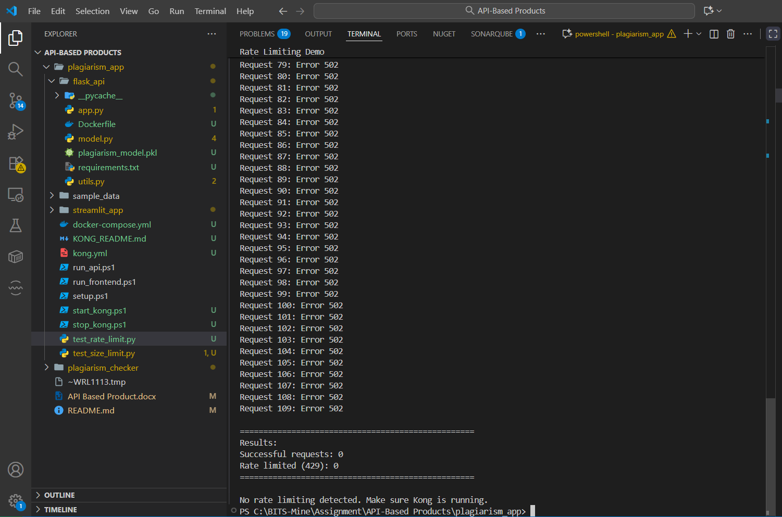

Request Size Limiting:

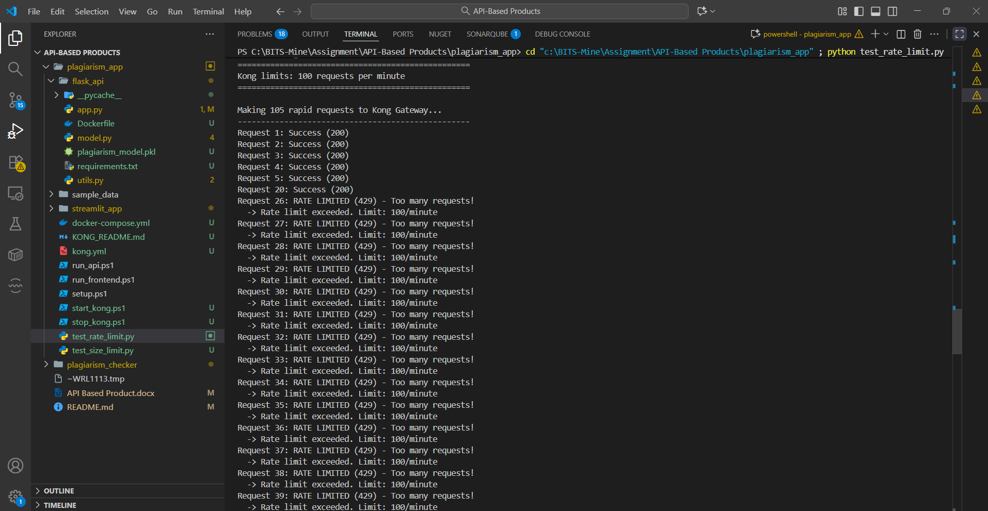

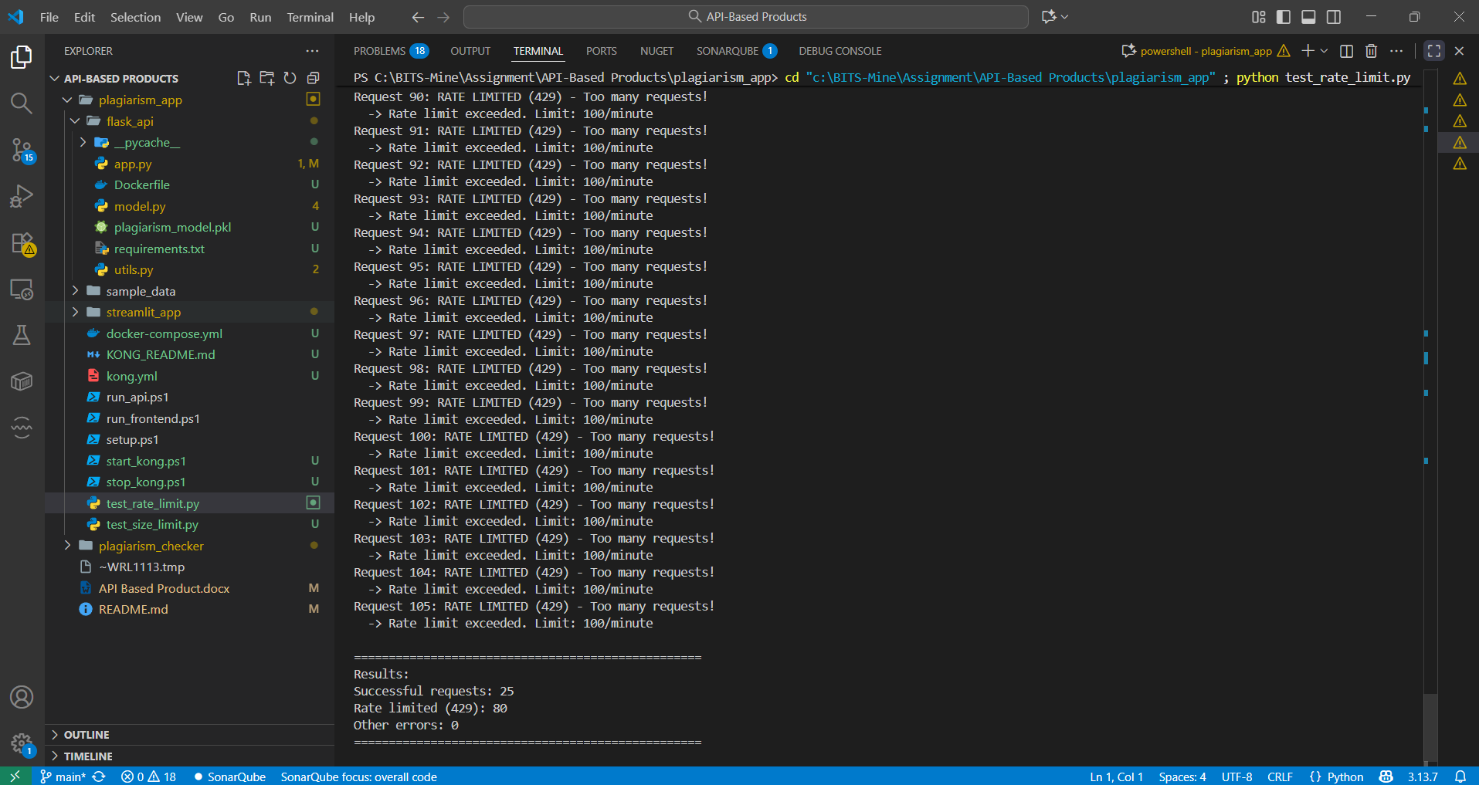

**Question 3: Implement TokenBucket and Leaky Bucket rate limiting algorithms in Java/Python/c#.**

I have implemented it in python.

Token Bucket Implementation:

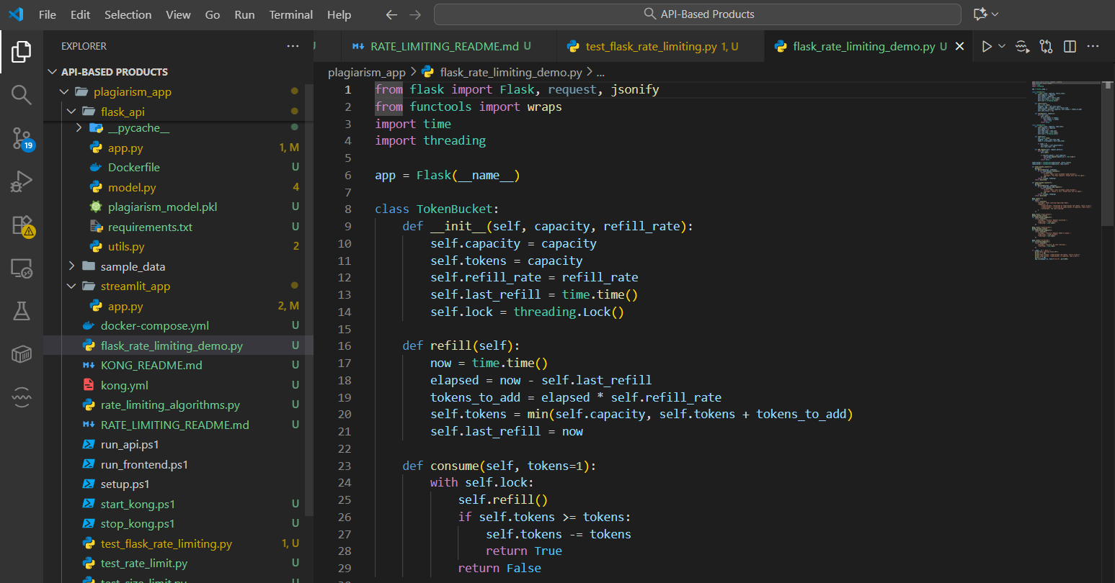

LeakyBucket Implementation:

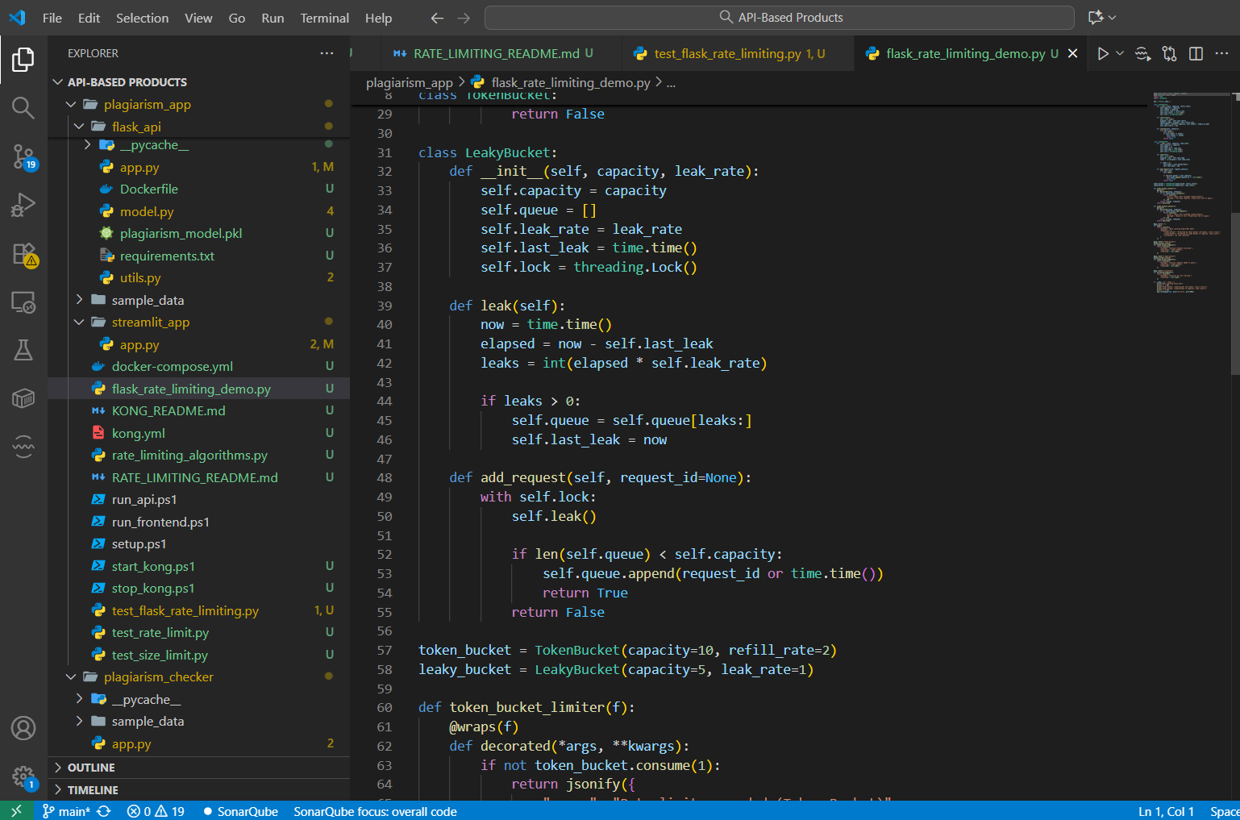

Token Bucket Algorithm Demo:

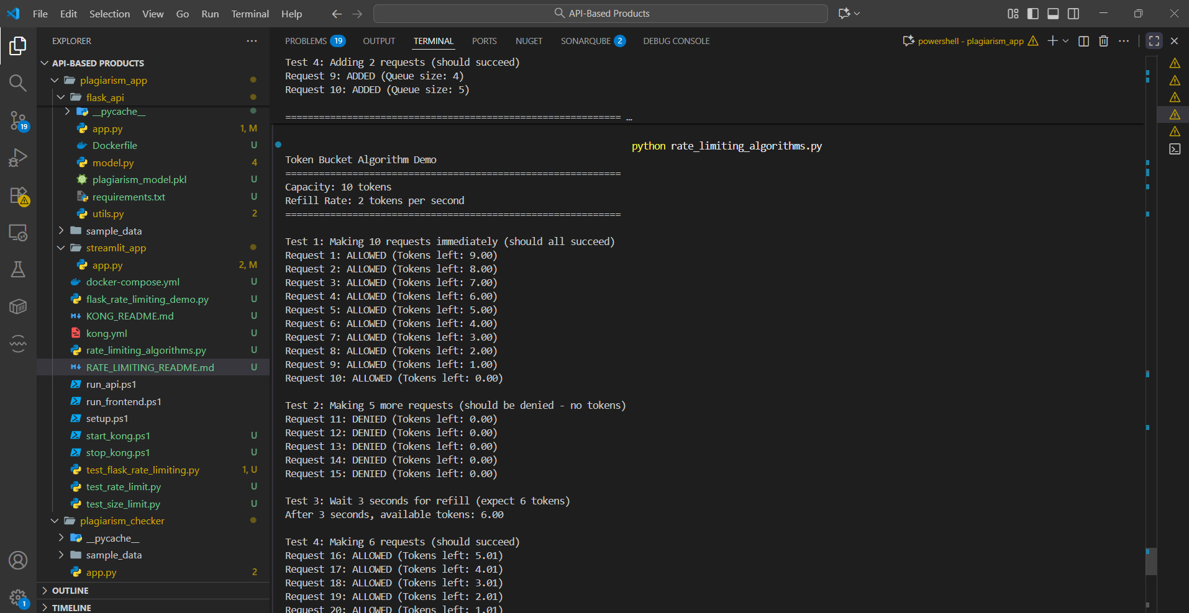

Leaky Bucket Demo:

